How will you consume a ReST based API request and produce a SOAP based API request in a message broker application?
Interview answer: I would use a message broker with a REST-to-SOAP transformation layer. The application receives the REST request, converts the JSON payload into a SOAP XML envelope, invokes the SOAP service, and converts the SOAP response back into JSON.

1. REST Client
|
| HTTP POST + JSON
| // Client sends request data in JSON format.
v
2. REST Controller
|
| Validate request
| // Spring Boot receives the request and validates
| // mandatory fields, data types, and business inputs.
v
3. Message Broker (Kafka/RabbitMQ)
|
| Publish message
| // Controller publishes the request to the broker.
| // The broker stores/routes the message for consumption.
v
4. Message Consumer / Adapter
|
| Consume message
| // Consumer reads the message from Kafka/RabbitMQ.
| // It maps the incoming data to the SOAP request model.
v
5. SOAP Client
|
| JSON / Java Object → SOAP XML
| // SOAP client builds the XML Envelope and Body
| // according to the SOAP service's WSDL contract.
v
6. External SOAP Service
|
| SOAP Request (XML)
| // External service processes the SOAP request
| // and returns a SOAP response or SOAP Fault.
v
7. Transform Response
|
| SOAP XML → Java Object / JSON
| // Adapter maps the SOAP response to the application's
| // response model and converts it to JSON if required.
v
8. REST Client
|
| Receive result
| // In an asynchronous broker flow, the original REST
| // request usually receives HTTP 202 Accepted + a tracking ID.
| // The client retrieves the final result separately.
|
| // For an immediate response, use a synchronous request-reply
| // design with correlation IDs and timeout handling.

Interview key point: Kafka/RabbitMQ handles message delivery; the adapter performs the REST-to-SOAP transformation and calls the SOAP service.
Important: With a normal asynchronous broker flow, Step 8 does not automatically receive the SOAP response on the original HTTP connection. You need a status/result endpoint or a deliberately designed synchronous request-reply mechanism.
Real World Example
Let's understand this with a real-world banking example: transferring money from one bank to another when your bank exposes a REST API but the external payment system uses SOAP.

Real-world example: Bank payment processing
Imagine you use a mobile banking application to transfer ₹5,000 to another account. Your bank's application uses REST, but an older external payment system accepts only SOAP.

Step-by-step flow
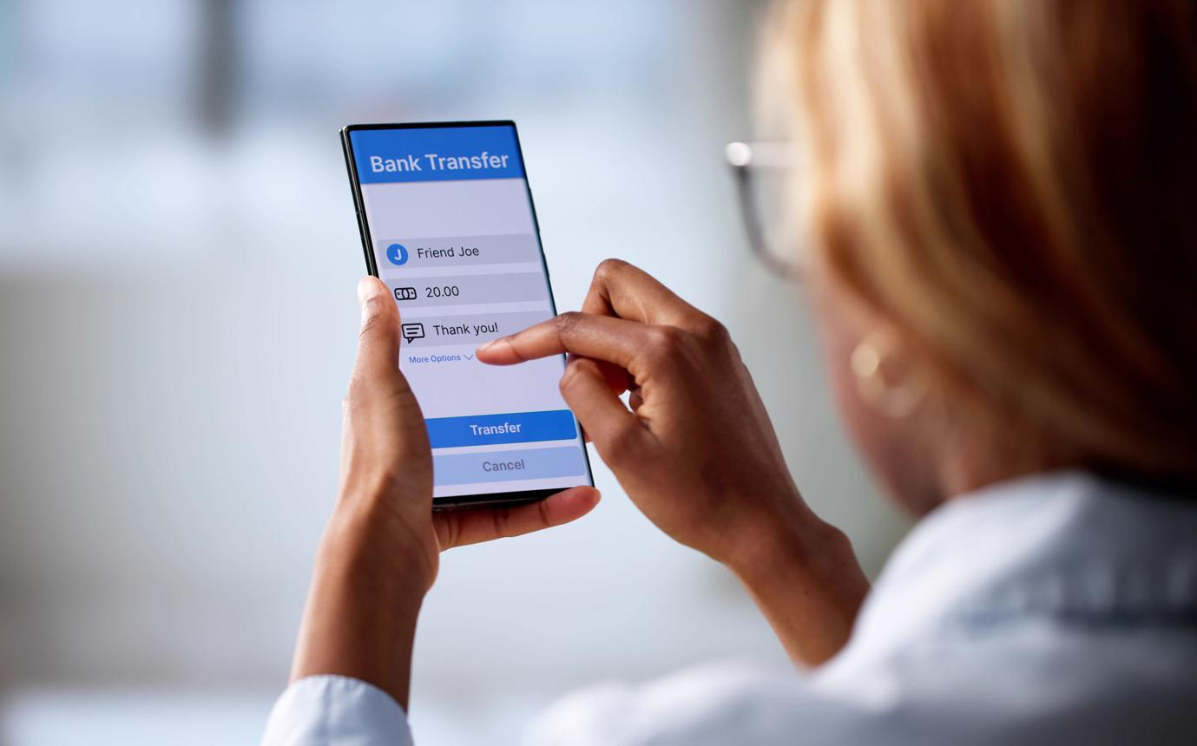
1. Mobile App → REST Controller
You enter the recipient account and ₹5,000, then tap Transfer.
Request: HTTP POST + JSON
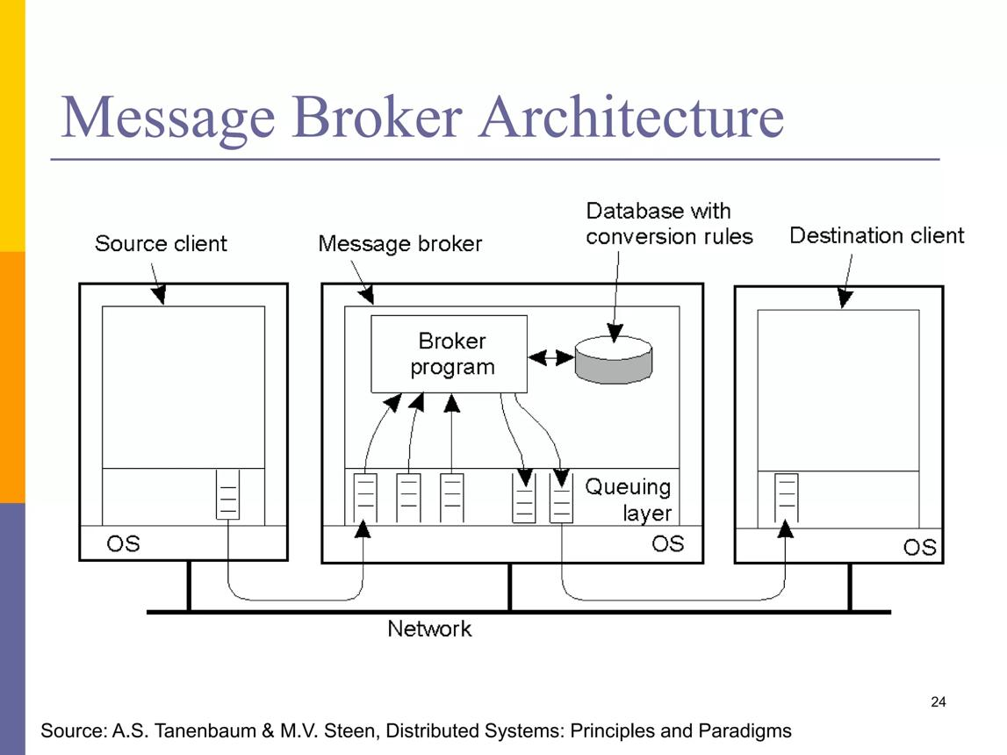
2. REST Controller → Kafka/RabbitMQ
The bank validates the request and publishes a payment message for asynchronous processing.
Message: PaymentRequested
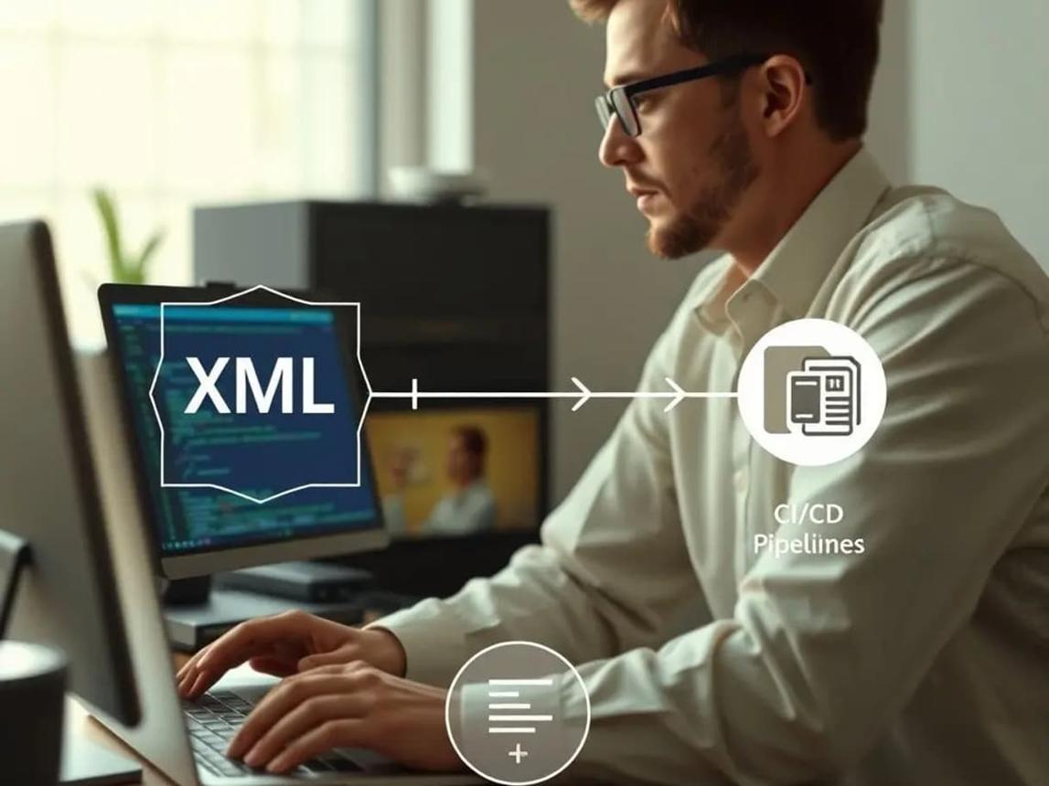
3. Consumer / Adapter
It reads the message and converts the payment data into the format required by the external SOAP service.
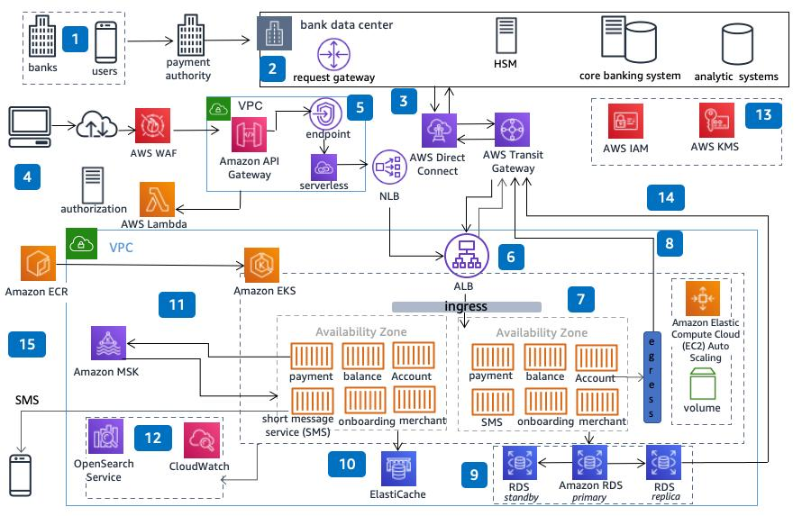
4. SOAP Client → External Payment System
The SOAP client sends the XML request. The external system processes the payment and returns an XML response.
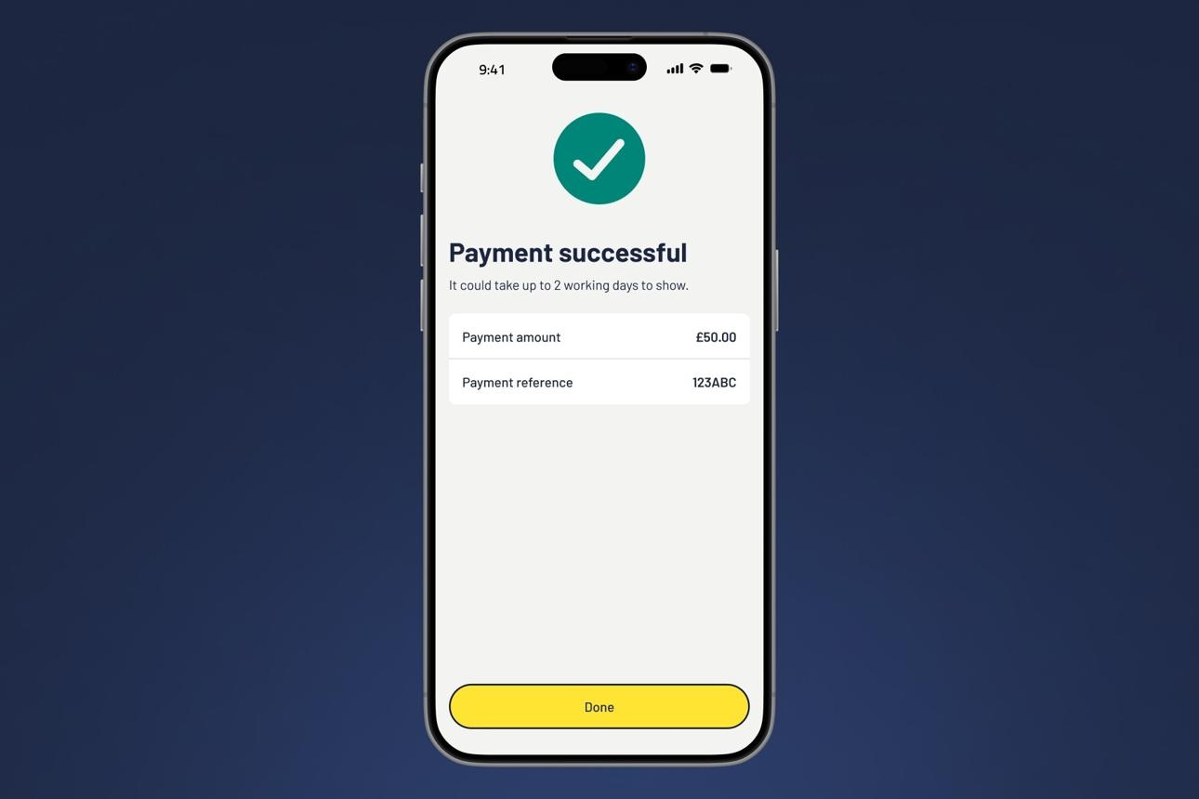
5. Response Processing
The adapter interprets the SOAP response and records the result. The mobile app can retrieve the final status using a payment reference.

Complete flow with comments
1. Customer / Mobile App
|
| Transfer ₹5,000
| // User initiates a bank transfer.
v
2. REST Controller
|
| POST /payments + JSON
| // Validates amount, account details and request.
v
3. Kafka / RabbitMQ
|
| PaymentRequested
| // Delivers the payment message to a consumer.
v
4. Payment Consumer / Adapter
|
| JSON → Payment Object → SOAP XML
| // Maps fields to the external system's WSDL contract.
v
5. SOAP Client
|
| SOAP Request
| // Sends XML over HTTP(S) to the external system.
v
6. External Payment System
|
| SOAP Response: SUCCESS / FAILURE
| // Processes the payment and returns its result.
v
7. Response Adapter
|
| SOAP XML → Application Result
| // Stores the result and updates payment status.
v
8. Payment Status API
|
| GET /payments/{paymentId}
| // Mobile app retrieves the final payment status.
v
9. Customer
|
| Payment Successful / Failed
| // Displays the final result.

Example of request transformation
REST sends JSON:
{
"paymentId": "PAY101",
"fromAccount": "111222",
"toAccount": "333444",
"amount": 5000
}
The adapter creates a SOAP XML request (illustrative format):
<soap:Envelope>
<soap:Body>
<TransferPayment>
<PaymentId>PAY101</PaymentId>
<FromAccount>111222</FromAccount>
<ToAccount>333444</ToAccount>
<Amount>5000</Amount>
</TransferPayment>
</soap:Body>
</soap:Envelope>
The actual XML elements and namespaces must match the external service's WSDL.

What if the SOAP service fails?
- Temporary failure: Retry with controlled backoff, subject to the service contract.
- Message keeps failing: Move it to a dead-letter queue for investigation.
- Duplicate delivery: Use the payment ID as an idempotency key to avoid processing the same payment twice.
- Response is delayed: Keep the payment status as PROCESSING until the outcome is known.
Interview takeaway: The REST API accepts JSON, the message broker decouples processing, the adapter converts the data, and the SOAP client communicates with the legacy system. Because the flow is asynchronous, the initial REST response is usually 202 Accepted with a payment reference—not the final payment result.

